Summary of the tech meetings

# Administrative questions

## Access to the service store

Are we supposed to have (read or write) access to the Service Store?

<https://store.interconnectproject.eu/ServiceStore>

Looks like only the consortium members could create an account

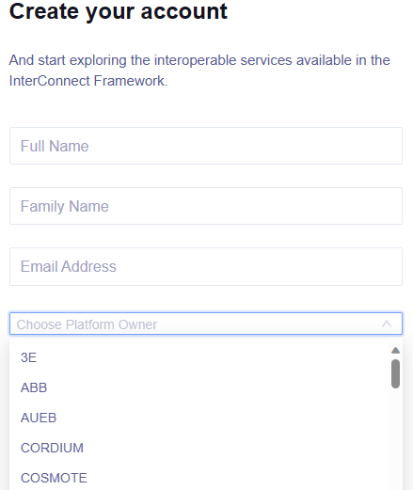

[serviceStoreKPIS Explorer (interconnectproject.eu)](https://store.interconnectproject.eu/ServiceStore/#/kpi/kpi-explorer)

## Access to standards?

There a few standards cited in the documentation such as IEC61850 and IEC61968

Do we have access to some standards that Interconnect or some of the consortium members have bought?

[EN 50631-1 (en-standard.eu)](https://www.en-standard.eu/csn-en-50631-1-household-appliances-network-and-grid-connectivity-part-1-general-requirements-generic-data-modelling-and-neutral-messages/)

# Technical questions

# Is there any side available where we can test the communication?

## How to deploy the software?

Where is this code deployed?

[project-SSAs/INESCTEC-Flexibility/FlexibilitySSA/FlexibilitySSA.py · main · InterConnect Public / service-specifc-adapters · GitLab](https://gitlab.inesctec.pt/interconnect-public/service-specifc-adapters/-/blob/main/project-SSAs/INESCTEC-Flexibility/FlexibilitySSA/FlexibilitySSA.py)

Generic adapter docker image

[Container Registry · InterConnect Public / Generic Adapter · GitLab (inesctec.pt)](https://gitlab.inesctec.pt/interconnect-public/generic-adapter/container_registry/313)

# What type of data the devices have to send?

## About the templates?

[examples/heatingsystem.ttl · develop-v1.1.2 · SAREF / saref4ener · GitLab (etsi.org)](https://labs.etsi.org/rep/saref/saref4ener/-/blob/develop-v1.1.2/examples/heatingsystem.ttl)

# Questions from the mentor

List of devices and communication?

Type of data that we are exchanging?

Price offer

Price Unit for KWA

Request from the grit to reduce the energy

On/Off

Power level (could be PWM)

Monitoring

Power consumption, ect